2.1 Recommended Project Structure
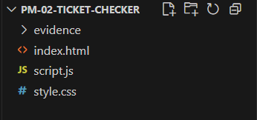

2.2 Basic HTML Shell for PM-02
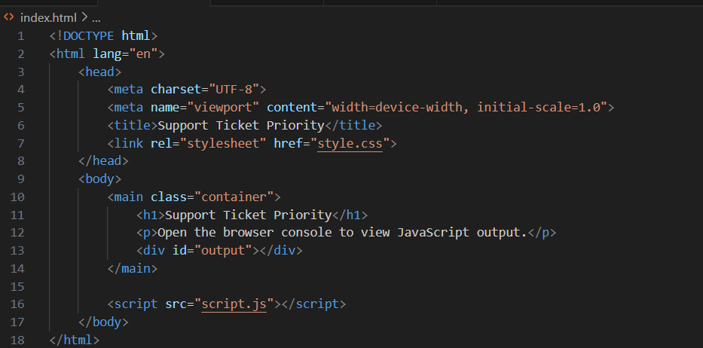

2.3 Basic CSS Shell for PM-02
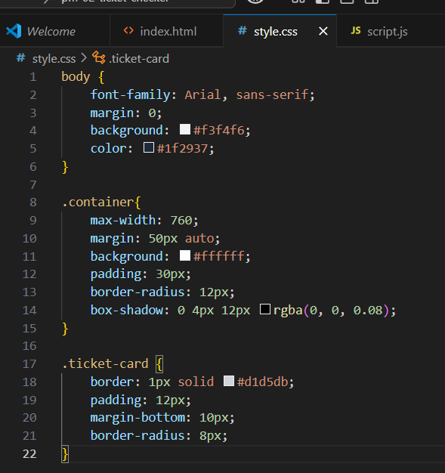

3.5 Practice Exercise 1
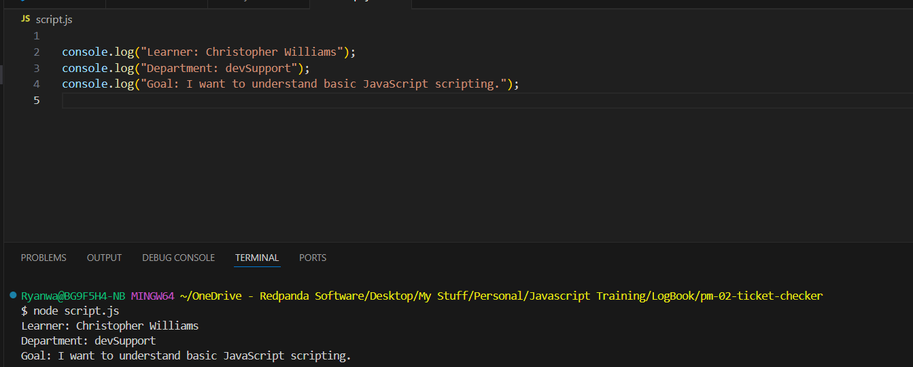

3.6 Activity 1 Checkpoint

What is a JavaScript statement?
It is an instruction. Each statement tells the browser or Javascript engine to do something.

What does console.log() do?
It is a testing tool that helps developers to display information in the browser console.

Where do console messages appear?
They appear in the Developers tools on the webpage when the developer press F12 they can to the console tab and find the console.log.

Why should learner’s save and refresh after changes?
Reason why the learner should do that is so they can see their changes appear on the webpage. By not following that action they webpage will not automatically update and refresh.

What is one common syntax error?
A common error in forgetting to close the brackets () or forgetting to close the quotations “”. If these actions are not corrected it will cause the JavaScript not to run.

Practice Exercise 2
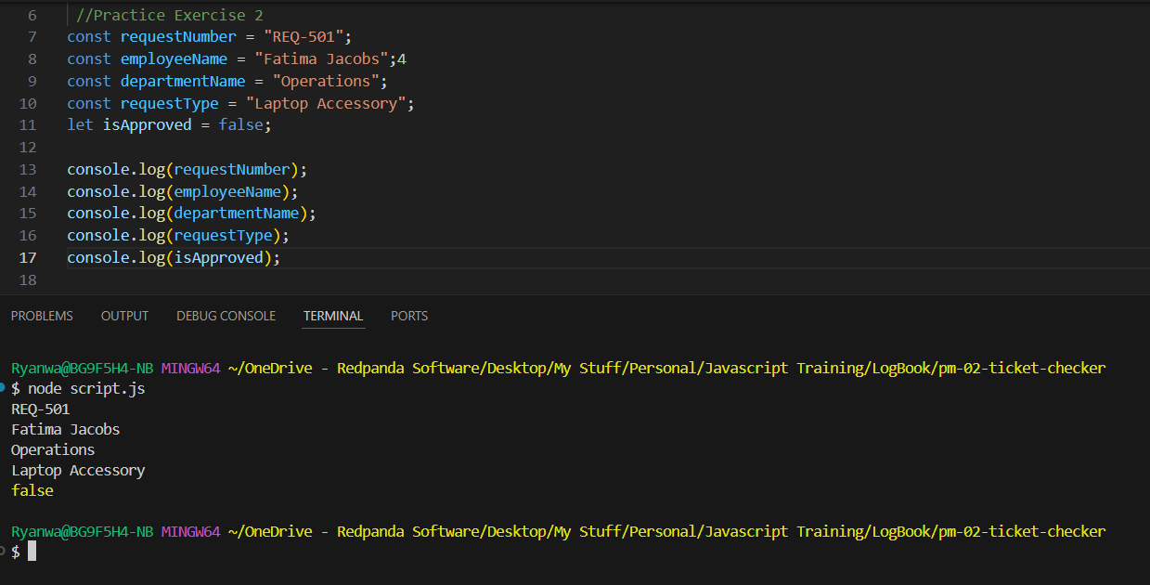

4.7 Activity 2 Checkpoint

What is a variable?
A variable is a named container for a value. The value can be used in a form to store information to help with calculations.

When should you use let?
Use a let on a value that can be changed like discount price on an item.

When should you use const?
Const should be used on a value that cannot be changed or reassigned, like the VatRate.

Why are meaningful names important?
Readable variable names are important as code is read often then it is written.

Can a const value be reassigned?
No, a const cannot be reassigned.

5.7 Practice Exercise 3
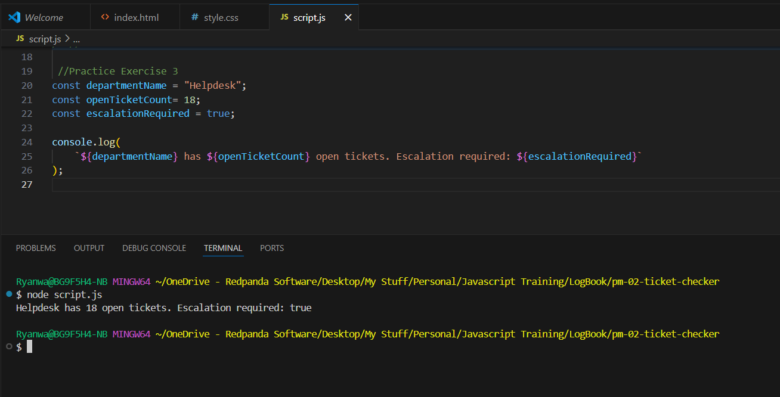

5.8 Activity 3 Checkpoint

What is a string?
A string is text. Strings are written quotes in both single and double.

What is a number?
A number is used for calculations and cannot be written inside quotes.

What is a Boolean?
A Boolean is used for making decisions that end with either yes or no. Value will need to be true or false.

What does typeof do?
Typeof can be used for checking the type of a value as it can help developers to troubleshoot.

Why is “10” different from 10?
One is identified as String/text and the other is identified as a number.

6.6 Practice Exercise 4
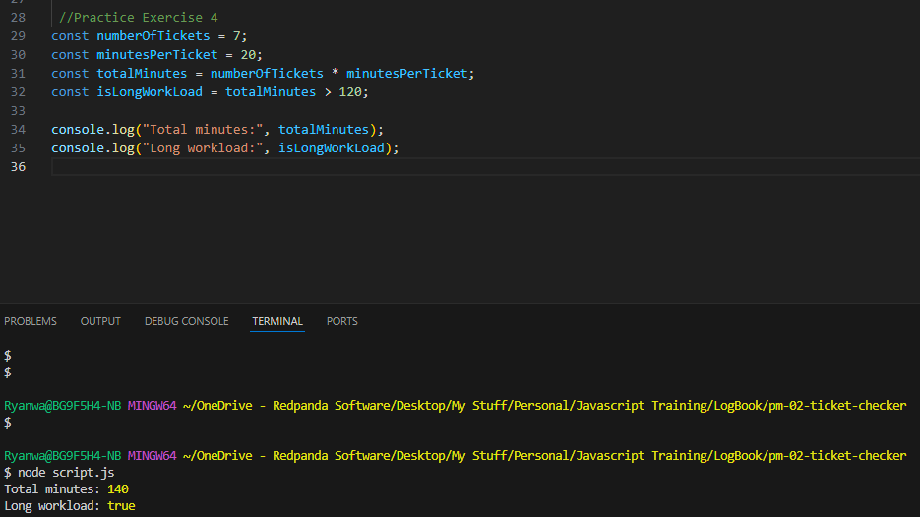

6.7 Activity 4 Checkpoint

What does an arithmetic operator do?
It allows the JavaScript to calculate, compare and combine values. This can be symbols like ‘+, -, *, /, %’.

What does === check?
This does a comparison where it will compare values. This one mean that it must value must strictly equal to the same.

What does && mean?
This operator means that both conditions must be true.

What does || mean?
This operator means that at least one condition must be true.

Why do comparison operators return true or false.
It is their job to test a condition similar to how Boolean produces results. Its job is to answer the question.

7.8 Practice Exercise 5
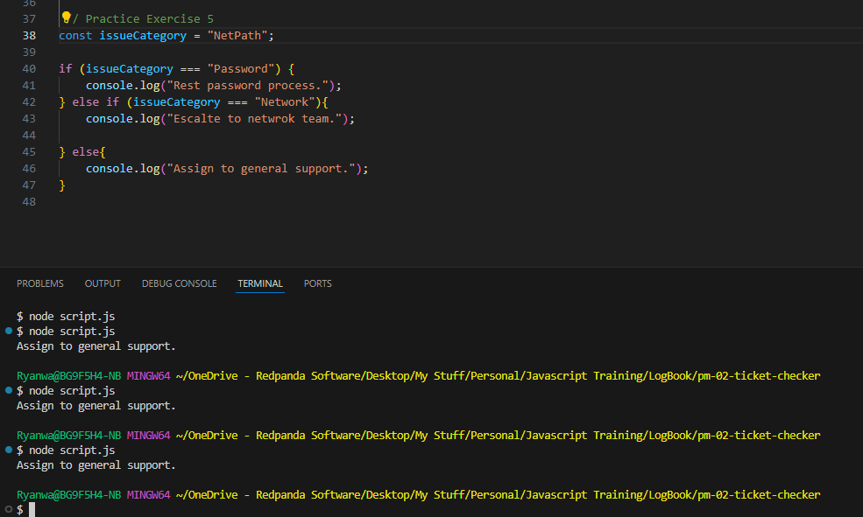
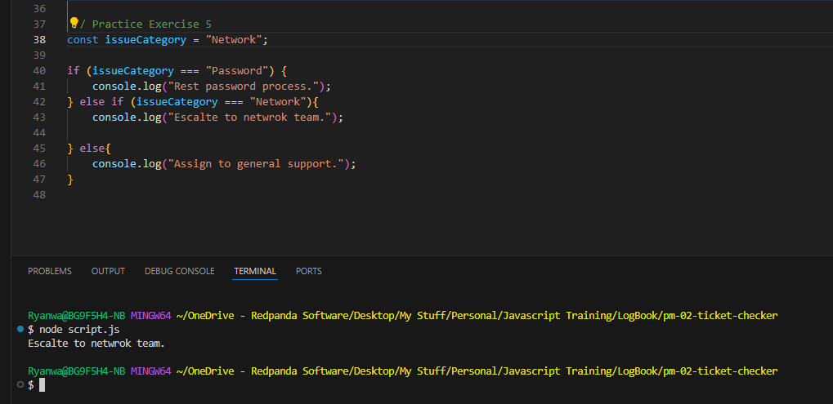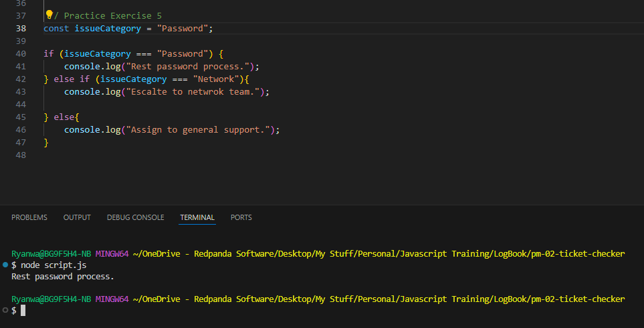

7.9 Activity 5 Checkpoint

What does an if statement do?
An if statement is a query that will run in a block of code and will only provide a result if true.

When should else if be used?
Else if should be used when there are multiple possible conditions

What is the purpose of else?
Else purpose is to push out a respond when the value does not match what is in the if statement or else if statement.

What does switch help with?
A switch can be useful when one value is compared against several possible cases.

Why should learners test all possible priority values?
Learners should do this so that they know that every possible outcome has been tested and to make sure that any errors or missing conditions are corrected.

8.7 Practice Exercise 6
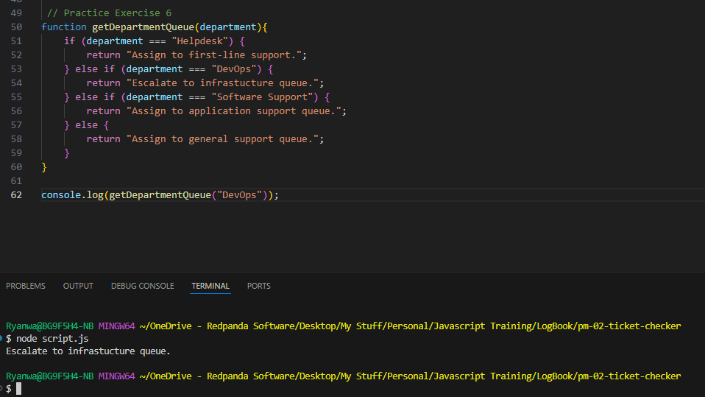
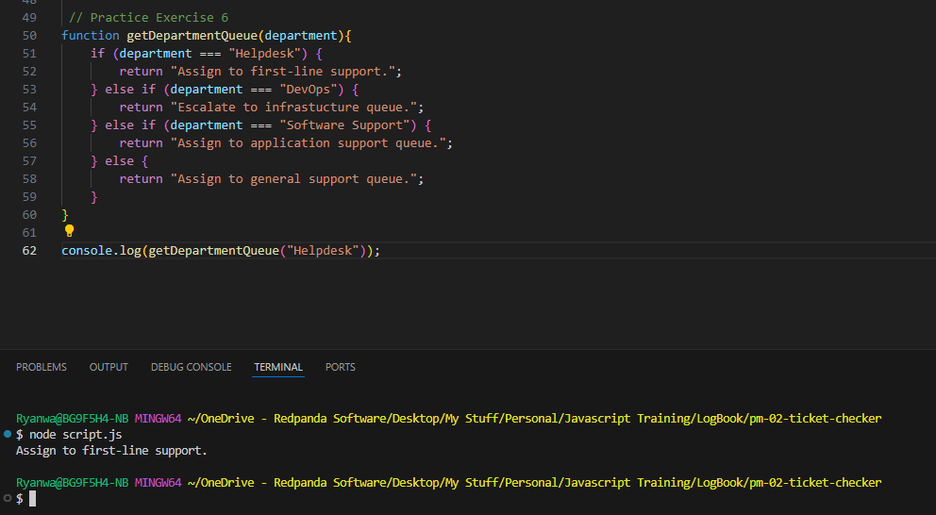
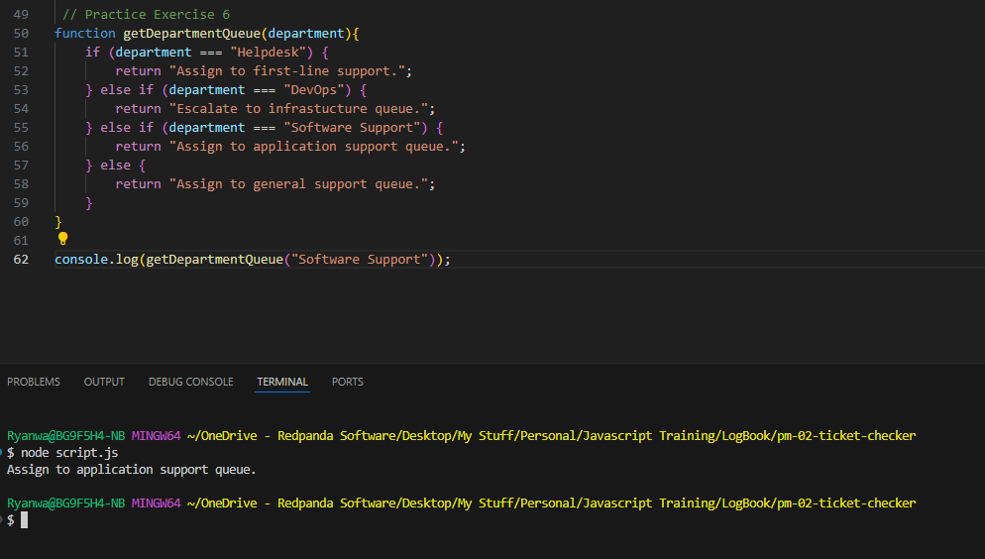
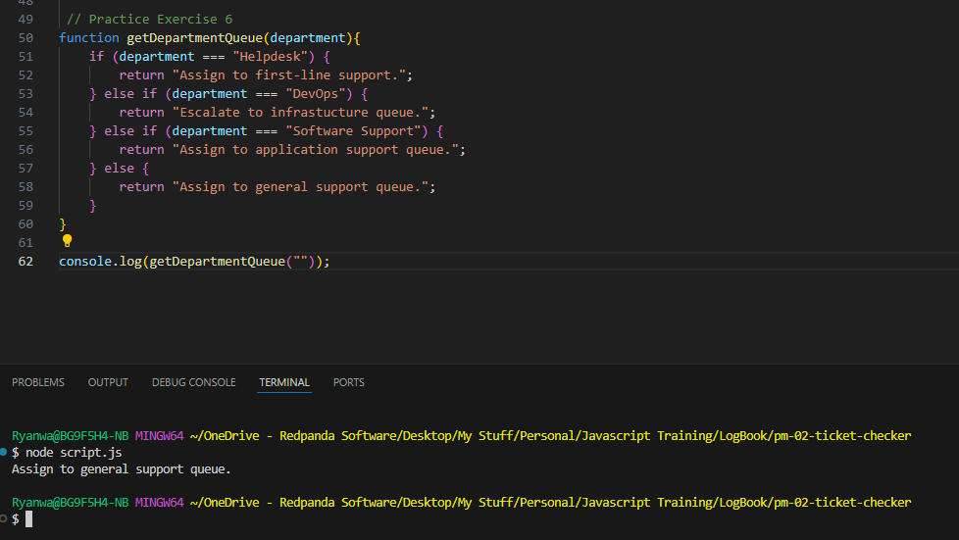

8.8 Activity 6 Exercise

What is a function?
A function is a reusable block of code that can allow the developer to logic inside the function and be able to call it when needed instead of needed to rewrite the same logic over multiple times.

What is a parameter?
A parameter is a value that is passed into a function and can make them flexible.

What does a return do?
A function can return a value instead of immediately displaying it. Returning values makes functions easier to reuse in different parts of a script.

Why are functions useful?
A function can be reused instead of needed to rewrite the same logic over.

Why should function names describe actions?
It will make the code easier to understand and use

9.7 Practice Exercise 7
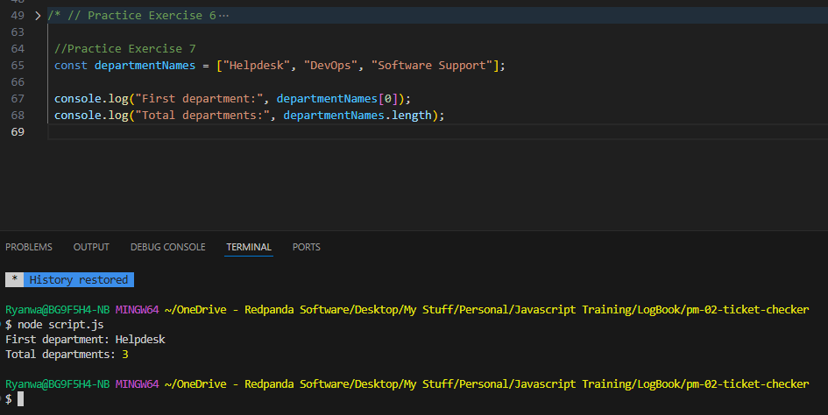

9.8 Activity 7 Checkpoint

What is an array?
An array stores a list of values, allows JavaScript to store and work with a list.

What index does the first array item use?
The first item will represent a 0.

What does .lengh show?
The length property tells the developer how many items are in an array.

What does push() do?
A push is used to add one or more items to the end of an array.

Why are arrays useful for support tickets?
A helpdesk may have many tickets or requests. Arrays can help them by allowing them to store and manage multiple tickets in one place.

10.8 Practice Exercise 8
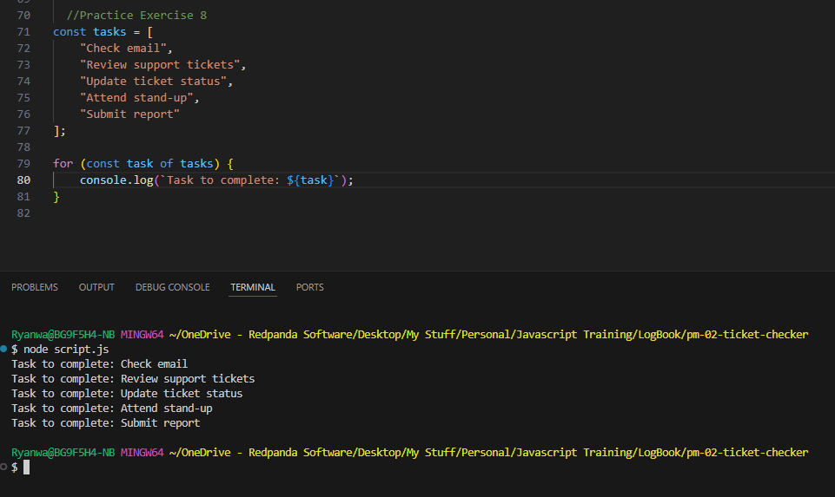

10.8 Activity 8 Checkpoint

What does a loop do?
It allows a program to repeat actions.

Why do arrays and loops often work together?
It lets the developer go through each item in an array one at a time as an array can store multiple items and the loop can process through each one.

What does priorities.length help control
It helps control a loop so it can process every item in the array

What is easier about for…of?
A for…of loop is often easier to read when the developer wants to process each item in an array without needing the index number.

How can a loop process multiple tickets?
A loop can process multiple tickets by going through each ticket in an array one at a time. The loop automatically repeats the same action for each ticket in the array. Making it easier as there will be no needed to rewrite the same code repeatedly.

11.7 Practice Exercise 9
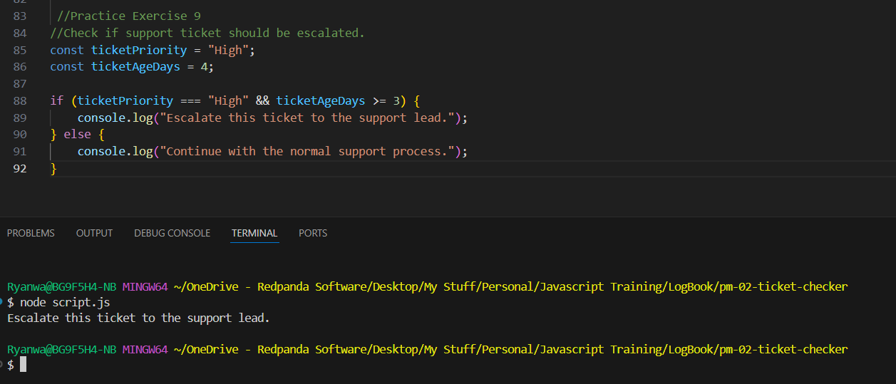

11.8 Activity 9 Checkpoint

What is a comment?
A comment is a note in the code that JavaScript ignores. Comments should explain why the code exists or clarify a step that may not be obvious.

What makes a comment useful?
It is useful as it will note break the actually code and give a short definition of what the code does.

Why is indentation important?
It is important because spacing code blocks can help the structure to make it easier to read and allow errors to be spotted easily.

What is camelCase?
It is when names are spelled first with a lowercase followed up with the second names first letter being with a Capital/uppercase Letter.

Why should code be readable even if it already works?
Code needs to be readable so that people to b able to understand it in case for future update builds or missing possible errors. Readable code is also easier to maintain.

